
COLLEGE OF COMPUTER STUDIES

CCS007L (COMPUTER PROGRAMMING 2)

EXERCISE
5

POINTERS

Student Name / Group Name:
Name Role

Members (if Group):

Section:

Professor:

I. PROGRAM OUTCOME/S (PO) ADDRESSED BY THE LABORATORY EXERCISE

• Design, implement and evaluate computer-based systems or applications to meet desired needs and requirements. [PO: C]

II. COURSE LEARNING OUTCOME/S (CLO)ADDRESSED BY THE LABORATORY EXERCISE

• Apply the fundamental principles of handling CString values, pointers and memory allocation, and structures using C++in solving computing activities [CLO: 2]

III. INTENDED LEARNING OUTCOME/S (ILO) OF THE LABORATORY EXERCISE

At the end of this exercise, students must be able to:

• Create a program that will traverse pointers on a given array and do some process
• Create a program that simulates some predefined C-String functions using pointers.

IV. BACKGROUND INFORMATION

A pointer is a variable whose value is the address of another variable. Like any variable or

constant, you must declare a pointer before you can work with it. The general form of a pointer variable declaration is:

Type *var-name;

Here, type is the pointer's base type; it must be a valid C++ type and var-name is the name

of the pointer variable. The asterisk you used to declare a pointer is the same asterisk that you

use for multiplication. However, in this statement the asterisk is being used to designate a

variable as a pointer. Following are the valid pointer declaration:

int *ip; // pointer to an integer

CCS007L-Computer Programming 2 Page 2 of 7
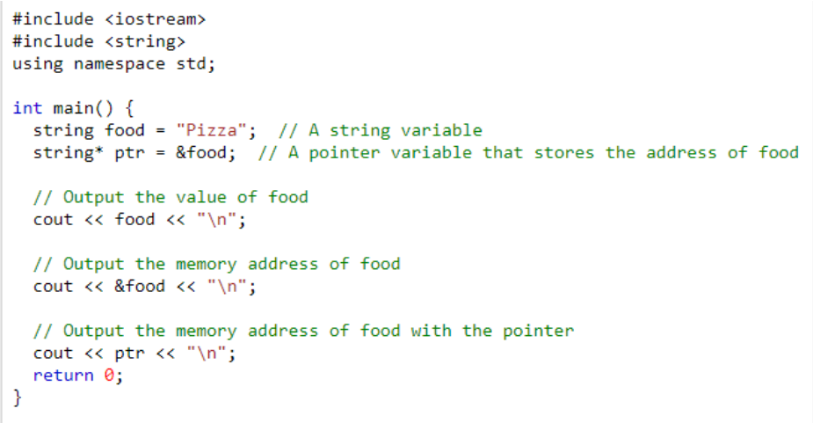
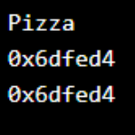

double *dp; // pointer to a double float *fp; // pointer to a float char *ch // pointer to character

The actual data type of the value of all pointers, whether integer, float, character, or

otherwise, is the same, a long hexadecimal number that represents a memory address. The

only difference between pointers of different data types is the data type of the variable or

constant that the pointer points to.

Simply, a pointer is a variable that stores the memory address as its value.

A pointer variable points to a data type of the same type, and is created with

the * operator. The address of the variable you're working with is assigned to the pointer:

Create a pointer variable with the name ptr, that points to a string variable, by using the asterisk sign * (string* ptr). Note that the type of the pointer has to match the type of the variable you're working with. Use the & operator to store the memory address of the variable called food, and assign it to the pointer. Now, ptr holds the value of food's memory address.

V. GRADING SYSTEM/ RUBRIC

CCS007L-Computer Programming 2 Page 3 of 7

Trait

Requirement Specification(30pts)

Data type(20pts)

Input Validation(20pts)

Free from syntax, logic, and runtime errors (10pts)

Delivery (10pts)

Use of Comments (10pts)
(Excellent) Able to identify
correctly all input and output and provide alternative.
(28-20pts)

Able to apply required data type or data structure and produce correct results (18-20pts)
The program works and meets all specifications. Does exception al checking for errors and out-of- range data (18-20pts) Unable to run program (10pts)

The program was delivered on time (10pts)

Specific purpose is noted for each function, control structure, input requirements, and output results. (10pts)
(Good)
Able to identify correctly all input and output
(25-17pts)

Able to apply required data type or data structure and produce partially correct results (15-17pts) The program works and meets all specifications. Does some checking for errors and out of range data (15-17pts) Able to run program but have logic error (8-9pts)

The program was delivered after 5 minutes from the time required. (8-9pts)

Specific purpose is noted for each function and control structure. (8-9pts)
(Fair)
Able to identify only one input or output (22-14pts)

Able to identify required data type or data structure but does apply correctly (12-14pts)

The program produces correct results but does not display correctly Does not check for errors and out of range data (12-14pts)
Able to run program correctly without any logic error and display inappropriate output (6-7pts)

The program was delivered after 10 minutes from the time required. (6-7pts)

Purpose is noted for each function. (6-7pts)
(Poor) Unable to
identify any input and output
(20-11pts)

Unable to identify required data type
(9-11pts)

The program produce s incorrect results (9-11pts)

Able to run program correctly without any logic error and display appropriate output (5pts) The program was delivered after 15 (or more) minutes from the time required. (5pts)
No comments included. (5pts)

VI. LABORATORY ACTIVITY

CCS007L-Computer Programming 2 Page 4 of 7

INSTRUCTIONS:
Copy your source codes to be pasted in this document as well as a screen shot of your running output.
ACTIVITY5.1: strcat function using pointers

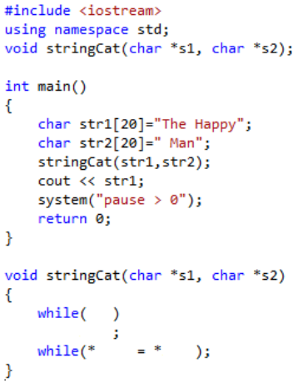
Complete the codes for the stringCat function. It will use the same function which is strcat function.

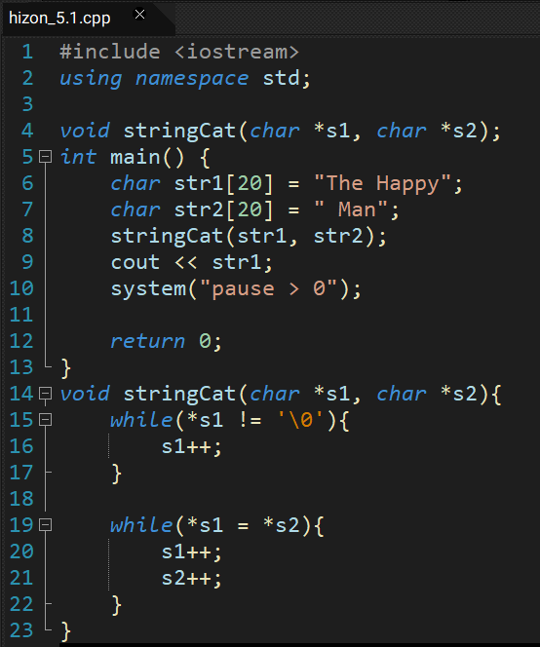
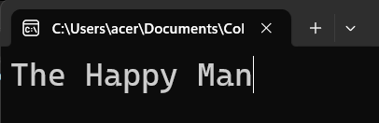

CCS007L-Computer Programming 2 Page 5 of 7
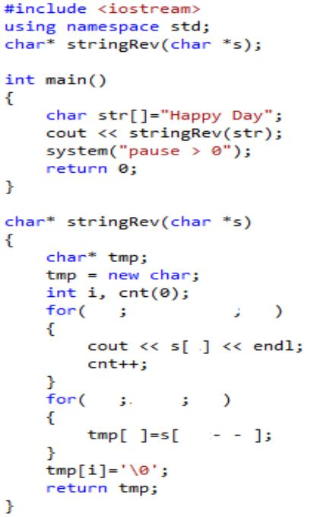

ACTIVITY 5.2: Reverse string Create a program that will return a reverse string using pointer.

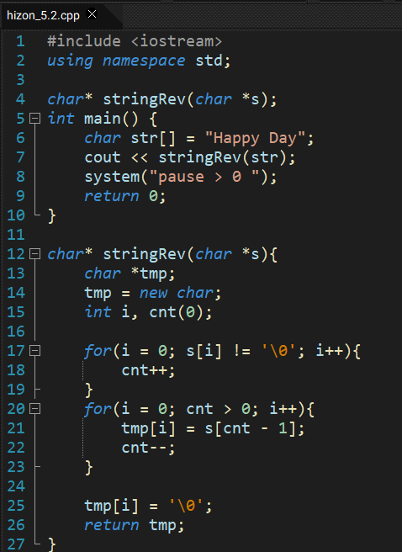

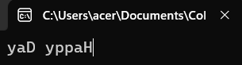

CCS007L-Computer Programming 2 Page 6 of 7

VII.QUESTION AND ANSWER

Briefly answer the questions below. Avoid erasures. For group activity, specify the name of GROUP MEMBER/s who answered the question. Do not forget to include the source for all NON-ORIGINAL IDEAS.

• How do you use pointers?

Pointers in programming languages like C and C++ store memory addresses, crucial for dynamic memory allocation and efficient data manipulation. They enhance flexibility and efficiency by allowing direct access to memory.
https://www.freecodecamp.org/news/pointers-in-c-programming/

• How do you create a dynamic array?

C creating a dynamic array involves using pointers and dynamic memory allocation functions like malloc() or new. The array is allocated with the desired size, and the pointer is used to manipulate it. Memory is released using free() or delete to prevent leaks.

https://www.guru99.com/cpp-dynamic-array.html

VIII. REFERENCES
• Zak, Dianne (2016). An Introduction to Programming with C++
• Deitel, Paul & Deitel, Harvey (2012). C++ How To Program, Eighth Edition • https://www.cprogramming.com/tutorial/lesson6.html

CCS007L-Computer Programming 2 Page 7 of 7

